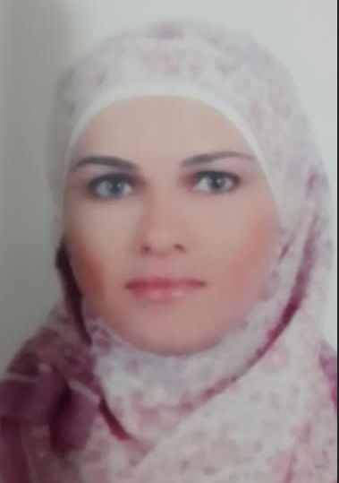

PERSONAL Profile

A detail oriented, high energy person who can fit in any difficult situation. I like to bring more value to the team by being a flexible member and I like to improve the working environment in order to achieve outstanding success as a result to my hard work.

- Date of Birth 31 /10/1982
- Nationality Jordanian
- Gender Female
- Marital Status Married (no children)
- Place of residency: Al Salmya –Kuwait
- Driving License: Valid (Jordan)

EXPERIENCE

Executive Secretary  Sony - Jordan | Aug 2007 – July 2015

- Secretary and Public Relations Executive.
- Follow up with everything related to the reception and operators. Follow with the phone calls and direct them to the correct people.
- Follow up with all the work related to the management, including writing formal letters, sending them to the right destination, filing them and receiving faxes with all related mails.
- Prepare meetings and follow with all the related matters.
- Prepare price offers and keep an eye on them with the right follow up.
- Follow with the employee issues including job offers, accepting letters, vacation, health insurance, etc.

Data Entry  American Kitchen - jordan | June. 2006 – July 2007

- Data entry for general information related to the company.
- Monitor customer appointments .
- Follow up the related issues for the customers in terms of picking up the right model and having it ready at their place.
- Follow up with the sales process.
- Keep clear records of all the related files.

Executive Secretary and An Accountant  AL Fan Computer Systems Company - Jordan | Feb. 2006 – Aug. 2004

- Customer reception.
- Follow up with the appointments.
- Follow up with the outcomes and incomes.
- Keep a save records of files.
- Follow with some issues related to accounting including the company invoices.

EDUCATION

Diploma Degree in Business Administration  Princess Tharwat College – Jordan | 2003

Tawjihi certified ‘High School  Dahiat Al Rashid School - Jordan | 2000

SKILLS

Languages | - Arabic: Mother Tongue  - English: good
Software | - Microsoft Windows  - Microsoft Office Tools
Presentation | - Developed ability to produce reports and presentations to a professional standard.
Interpersonal/Communication | - Strong team working, leadership and communication skills with ability to work and perform under pressure balanced by effective time management skills

AWARDS & ACTIVITIES
Other Training / Certificates

Training in Jordan Telecom Company at (Al-Abdale Service Center) In February 2002.

